Per Wijnands – Mutsaersstichting (The Netherlands)

Adventure Therapy in the backyard with families
In the organization Mutsaersstichting, we do a lot of family-trajectories with an AT-approach. The Adventure Therapist provides such a trajectory together with a system- or family-therapist. In our experience, the combination of an Adventure-Therapist and system- or family-therapist brings a synergetic effect and makes therapy more effective and mostly successful.

Summary
A trajectory can look like the table below. You will see that an AT-trajectory is divided over 10 sessions. Each session lasts 1 ½ - 2 hours. We have got a main goal for the family and goals for the individual members of the family. The goal of each session is related to the main goal. A trajectory lasts about 3 – 4 months. The sessions all take place on the terrain of the Mutsaersstichting, or nearby the Mutsaersstichting (in the backyard!). Adventure Therapy is mostly not the one and only method of treatment for a family or individual. Within a multidisciplinary team the treatment is shaped.

Session  Nr. | Goal | Activity | Development
1 | Acquaintance | Full value contract, conversation, Slackline
2 | Observation | Full value contract, tree basket, table of 3 | Destiny (oldest daughter) indicates that she doesn’t want to participate today. The rest of the family decides to participate and they “leave the door open” for Destiny in case she wants to join in later on. Destiny decides to leave after 40 minutes. Her parents are at first angry, disappointed and sad, but later they focus on the positive aspect (she stayed for 40 minutes) and they want to share this with Destiny.
3 | Teamwork | Hoops around a tree trunk | Destiny didn’t come to the therapy session today. There was an intense conversation between Destiny, her mom and the supervisors of her group. Destiny’s parents have difficulties with the fact that the supervisors do some much for Destiny and she doesn’t do anything back for them.
4 | Teamwork, being there, goal setting, safe environment | Mohawk Walk | Destiny does not directly participate in the activity but she does provides constructive advices and pays attention to the safety of her family. Mother is the leader, but doesn’t listen to the needs of the other family members, she does her own thing. The parents see the participation of Destiny as a small thing. As we deepen this further they see that her contribution has been very big. That’s what they can communicate with Destiny.
5 | Safety and trust | Magic Rope, how high will you deposit the wimp | Again Destiny doesn’t immediately joins the activity, but again she gives advice and pays attention to safety. The family tends to set the bar very high. They find out that it sometimes may slightly be lower
6 | Communi-cation, teamwork | Inside Out, Blind square (triangle) | At first, the families’ thoughts are based on assumptions which they don’t check. Because we use a blindfold everyone is much more precise in tuning in with each other and they check their assumptions. Parents tend to see only the negative side of Destiny because of their emotions and they forget to nominate the positive sides. The mother is making more progression in this than dad. Destiny does participate actively in the first activity and helps and ensures the safety during the second activity.
7 | Teamwork, fun, giving and receiving compliments | Full value contract in a different way, poles dance, most beautiful ball, the 4 elements | Strikingly, Destiny initially has said that she’d rather not participate, but she participates in everything even with a smile. There is cooperation/ teamwork, consultation, goal setting which appears to be too high so they are adjusted. The family communicates what their needs are to each other. And in another activity the family gives and receives compliments to/from each other.
8 | Mindset, victim role vs. responsible role, expectations towards each other | Helium stick, Mindset | Father has especially the victim role and has high expectations towards his family. The other family members see that father has a victim role instead of being a rock in the family (the ‘Pater Familias’).
9 | Expressing expectations towards each other | Expectations/ stones in daypack + slackline | There are a lot of expectations towards each other. Because we replaced the expectations by rocks it’s a very heavy load. It’s not possible to move it from its place. The family starts with a discussion about which expectations can be thrown away. Mother combines all her expectations to one which is “respect for each other”. She is very emotional when she gives meaning to/ explains her expectations, she feels alone – like she has to do everything in the house by herself. Father realizes that he isn’t there for his kids and that it is disrespectful towards them. If he wants to receive respect he also has to give/show respect. Destiny experiences that her parents often only see the negative things of her and her siblings and is wondering whether they are their burden.

Target Group
This family consists of a father of 40 years, a mother of 38 years, two daughters of respectively 14 (Destiny) and 9 years old and a son of 12 years. Father has a full-time job as a production assistant, mother works part-time in the recreational sector. Within the family they are maternal familiar with psychiatric problems among other things such as alcohol, schizophrenia. Mother had a difficult childhood, felt not seen, not supported by her parents, as an adult she has regularly suffered from depression.
Father is a quiet, closed man who finds it hard to be there for the children. Father comes from a family in which the rules of the parents were laws. This hierarchy/ clarity has father in mind to do well with his own children. Because of physical and psychological symptoms father is often very tired when he comes home from work.
Mother is more open in her contact with others, moves much along with father or with her eldest daughter (Destiny). Destiny is registered with depression, self-harm and suicidality. She goes to school, achieves good results but the contacts with classmates are difficult. She is a very fragile girl, who does not know how she can ask adequately for attention.
During the system therapy the following themes were revealed: communication among themselves, filling in for each other and an inability to speak about things. Children who have a great need to do activities together like it had been before. The partnership relation that sometimes ‘boils over’.

Trainers
Trainer/Therapist is Per Wijnands. Competences:
Understanding Psychopathology | Understanding of goals and what the next steps are to achieve these goals
Being able to follow the process | Can communicate on the same level as the client
- Creative | Understanding of (behavior) issues
- Creating a Safe environment (both mental and physical) | - Knowledge of the experiential learning methodology
- Being able to Report to others | - Reflective ability (including meta-level)
- Development-oriented | - Can Improvise
- Willing to get the best out of others | - Can coach
- Has the right attitude | - Authentic
- Ask questions and does not judge | Is not afraid of confrontations
- Does not want to stand in the ‘picture’, the client and his actions are the main focus | Knowledge of Adventure Activities in the domain of instruction and safety
- Knowledge of First Aid

Adventure Therapy is within the ‘Mutsaersstichting’ a solo-function, belonging to the field of occupational therapy. Various disciplines are deployed within the ‘Mutsaersstichting’ to work towards the goals of clients.

Methodology
- The zone of proximal development (described by Vygotsky). For example: when a child can already do something, but the next stage of development is almost there. The child can crawl and almost wants to stand. By responding to this and creating opportunities so that the child can stand in the exercise, you are working on boosting within the zone of proximal development. So you put the child not far from a box so the child can crawl to the box and pull up to it.
- Comfort Zone - Stretch Zone - Stress Zone
- NLP 'leveling' (create report) and 'anchor'
- Solution focused working
- Mindset and attitude (victim role <-> responsible role)
- Focus strategy: The main change of the mindset is that the focus shifts from avoiding to reaching. In other words, from fundamental thinking 'get away from problems, risks and failure' to fundamental thinking 'chances, opportunities, challenges and results. We shift the focus to where we want to go. When the goal fits into the vision of the greater good and no damage has been done, then the focus controls all the energy in the right direction.
- Elements of experiential learning (Full Value Contract) Challenge by Choice, Kolb's learning cycle
- Active Reviewing
- Debriefing/ Reflection: What, so what, now what
- Transfer to daily practice
- Meta Reflection: The trainers evaluate the session and set the direction for the next session.
- In addition to the above issues, we often use a metaphor during the Experiential Learning activities. This way, the operation of the method becomes even more effectuated.

Why using this practice?
Our starting point is the competency model: these young people do not get to their developmental tasks because the balance between psychopathology and stress factors outweighs the protective factors on the other side, thus the youngster can’t sufficiently learn skills that contribute to the establishment of the development tasks. By using AT, you practice skills (in the case above: shift focus and set goals) and increases your protective factors (Confidence and Self-reflection increases) so that the scale is more balanced and the client thus is more attributable to its development tasks. Through practicing all this in the therapeutic setting (zone of proximal development) you create a safe learning environment.

Psychopathology
Stressors
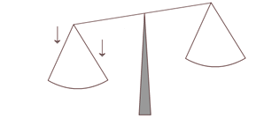
Protective factors
Development tasks
Skills

Components of Adventure Therapy
When children are registered in the Mutsaersstichting we don’t only treat the child but also the entire system. The parents come along with their child to ask for help for the problems they are experiencing. When it becomes clear that it is a ‘system problem’, the whole family is invited to work together on the issues.
Quite some time ago we started to combine the family system therapy in certain families with experiential learning. It may be possible that there have been several meetings with the system therapist and the family has been working hard on the issue already. By going outside along with the experiential learning coach and by doing very simple exercises, types of games, the family can practically experience what they have learned in the room.

With this combination of system family therapy and experiential learning we work with activity themes that are important for the family. The experiential learning trainer introduces the activity, puts the family at work and while working we dwell on what happened to everybody, what this does to each other, what can you yourself, what do you need from someone else, etc. How could you do this as well? The system therapist recognizes the patterns discussed in systemic psychotherapy, and makes them more negotiable, they are explored within the therapy and this makes individual family members more aware of their actions.
By dividing the tasks of the system therapist and experiential learning therapist and by complementing each other, we let families experience things together and to arrive at new insights, solutions. In addition, the system therapist can use these experiences again in their discussions with the family or within the partner relationship therapy. This can significantly shorten the treatment.
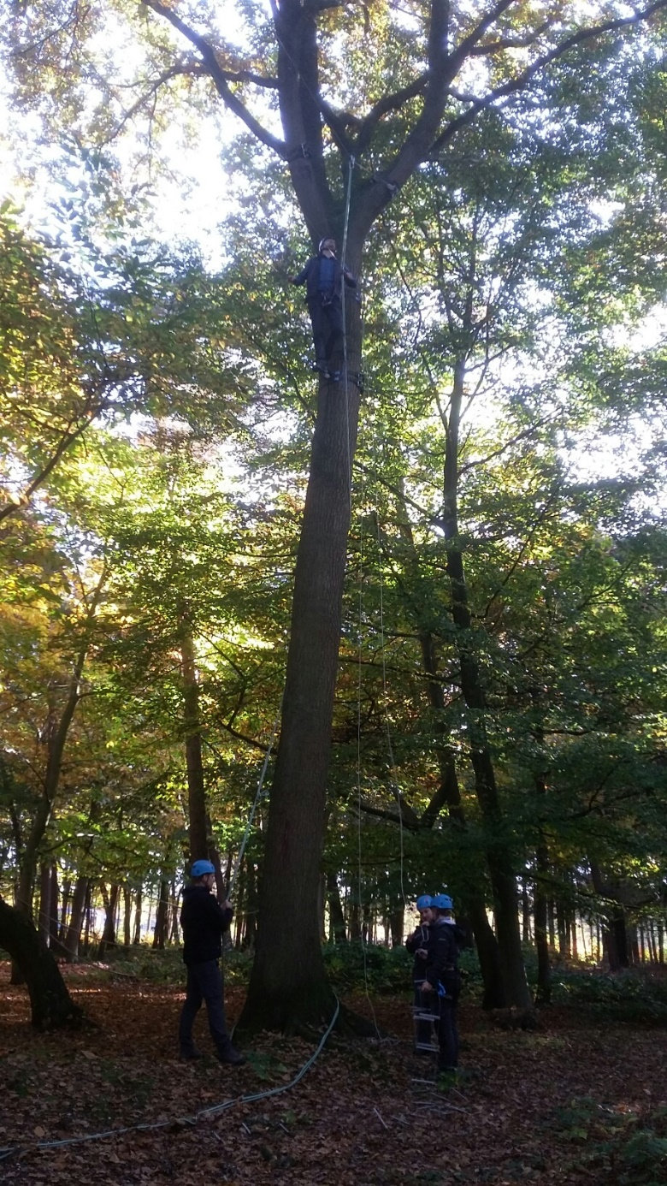

References
Reports of the internal report-system of the Mutsaersstichting.
Experiences of Per Wijnands doing Experiential Learning and Adventure Therapy in de organizations of Gastenhof and St. Anna (both Koraalgroep), Passe-Partout Zorg and Mutsaersstichting
Reader Ervaringsleren (2015, Team-Focus) authors Dennis Leufkens, Per Wijnands

Bacon, S. (2003) The Conscious Use of Metaphor in Outward Bound. (Duitse vertaling: Die Macht der Methaphern, Augsburg, ZIEL)

Bouman, F. (1998) Managementtraining in de buitenlucht, Gewoon buiten of buitengewoon? Assen, Van Gorcum&Comp

Brown, M. (2008) Comfort Zone: Model or metaphor? Australian Journal of Outdoor Education, 12(1), 3-12, 2008

Chaiklin, S. (2003) The zone of proximal development in Vygotsky’s analysis of learning and instruction. https://people.ucsc.edu/~gwells/Files/Courses_Folder/documents/chaiklin.zpd.pdf

Choy, J. (red.) (2012) De vraag op het antwoord. Santpoort Zuid: NISTO Publicaties

Didden, R. (red.). (2006) In perspectief. Gedragsproblemen, psychiatrische stoornissen en licht verstandelijke beperking Houten: Bohn Stafleu van Loghum.

Dewey, J. (1999). Ervaring en opvoeding. Houten: Bohn Stafleu van Loghum.

Du Prie, H. (1991) Ervaringsleren als ordeningsinstrument: arbeidsprojecten bij de Scheltemalaan Tijdschrift voor Jeugdhulpverlening en Jeugdwerk, vol. 3, afl. 5, p. 41-44

Galama, J., Kuiper, A. (2009) Reviewingtechnieken, Uitgever Thema

Gass, M.A., H.L. Gillis, K.C. Russell (2012). Adventure Therapy, Theory, Research, and Practice. Routledge, Taylor & Francis Group, LLC

Hattie, J., Marsh, H.W., Neill, J.T. & Richards, G.E. (1997) Adventure Education and Outward Bound: Out-of-Class Experiences that make a Lasting Difference Review of Educational Research, vol. 67, afl. 1, p. 43-87

Heap, M. (2008) The validity of some early claims of Neuro-Linguistic Programming. Skeptical Intelligencer, Vol. 11, 2008

Helmantel, H. (1991) Ervaringsleren: beginselen, mogelijkheden en toepassing Tijdschrift voor Jeugdhulpverlening en Jeugdwerk, vol. 3, afl. 5, p. 31-35

Helmantel, H. & Hilhorst, N. (1991) Invoering Ervaringsleren Tijdschrift voor Jeugdhulpverlening en Jeugdwerk, vol. 3, afl. 5, p. 50-52

Herbert, J.T. (1996) Use of Adventure Based Counseling Programs for Persons with Disabilities Journal of Rehabilitation, vol. 62, afl. 4, p. 3-9

Jager de, H., A. Mok, (1971) Grondbeginselen der Sociologie Leiden: Stenfert Kroese.

Kerp, R. (2009) Attitude. Een mooi woord, maar wat heb jij daar nou aan? ISBN 9781445202860, Kerp&Company

Lipchik, E. (2002) Beyond Technique in Solution-focused Therapy: Working with Emotions and the Therapeutic Relationship. New York – London: The Guilford Press

Nadler, R.S., J. Luckner. (1992). Processing the adventure experience Dubuque, VS: Kendall Hunt

O’Connor, J., J. Seymour. (2002). NLP-gids voor optimaal functioneren. Haarlem: De Toorts

Piaget, J., B. Inhelder (1955). Growth of logical thinking Londen: Routledge and Kegan.

Ploeg van der, J.D. (2011). Ervaringsleren, Theorie en praktijk. Rotterdam: Lemniscaat

Ringer, M., L. Gillis jr. (1995) Managing psychological depth in adventure programming Journal of experiential education 18(1) pp. 41-51.

Ruikes, T.J.M. (1994) Ervaren en leren: theorie en praktijk van ervaringsleren voor jeugdhulpverlening, jeugdbescherming en jeugdwerk Utrecht: Uitgeverij SPW

Ruikes, T.J.M. (2000) http://www.ervaringsleren.nl/wsn16DB.html

Scharloo, M. & Van Den Thillart, W. (1996) Afgeschreven, maar niet perspectiefloos Tijdschrift voor Jeugdhulpverlening en Jeugdwerk, vol. 3, afl. 5, p. 3-8

Schoel, J., Prouty, D. & Radcliffe, P. (1988) Islands of Healing: a Guide to Adventure Bases Counseling Project Adventure

Slot, N.W., H.J.M. Spanjaard (2000). Competentievergroting in de residentiële jeugdzorg. Hulpverlening voor kinderen en jongeren in tehuizen Baarn: Intro.

Slot, N.W. en H.J.M. Spanjaard, 2004, Competentievergroting in de residentiële jeugdzorg HB uitgevers Baarn.

Spiering, H. (2000) Spel als Motor; ontwikkelingsgericht onderwijs laat spelenderwijs leren NRC Handelsblad, 23 september 2000

Tuckman, B.W., & Jensen, M.A.(1977). Stages of small group development revisited. Group and Organization Studies, 2, 419-427.

Tuckman, B.W. (1965). Developmental sequence in small groups Psychological bulletin, 63, pp. 384-399.

Author
Per Wijnands (1967)
Social worker with specialization in Experiential learning and Adventure Therapy.
Since 2003 working with vulnerable youth in the area of Experiential Learning and Adventure Therapy.

PWijnands@Mutsaersstichting.nl
www.mutsaersstichting.nl
https://nl.linkedin.com/in/perwijnands

