Nadia Vossen & Lynn Van Hoof – NATURE (Belgium)

Good practice: “The step”

**1. What is it?**

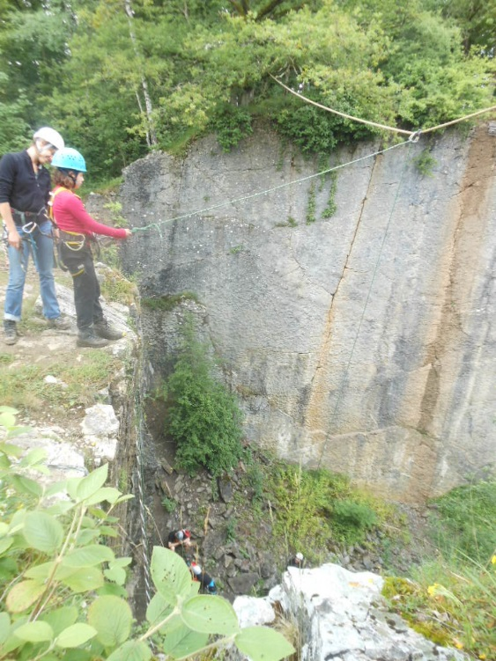

The good practice we would like to share is what we call “the step”, because it has a very strong therapeutic power. You take physically a step of the rock hanging in lines. At the same time it is a symbolic step into the here and now and into the future. Questions could be: ‘What do you leave behind?’ Or ‘Where do you step away from?’ And ‘where do you want to go? Or ‘Where do you step towards to?’ In the several programs we have done with youth at risk, this is a very strong metaphor. To prepare and focus on these questions we combine it with a “solo” walk before, where the ending point of the solo is “the step”. The step creates an opportunity to literally take a step into the void connecting it to a metaphor to a step in your life at that moment. What do you want to leave behind and what do you want to take with you? During the activity a lot happens to the participant who is on the edge, so you facilitate and reflect during the exercise, but also afterwards in the group to share their experiences if they want.

**2.** **Who is the target group?**

We use this activities mostly with youth at risk. But we as adult trainers also did the exercise and could feel the power and learning and healing potentials of it.

**3. Who are the trainers/educators? What are their competences?**

The set-up of the step requires a specific technical knowledge. It is an activity invented and used by “NATURE”. Once the set-up is made you need two trainers at least. But it is more comfortable with three trainers. You need one above to guide and counsel the participants on 2 levels: (1) technical/security; (2) emotional guidance, containing, therapeutic, taking their own step in life. And below you need 4 people to belay, one or two trainers assisted by fellow participants. By including participants in the activity and safety part it gives a lot more possibilities to the group members for experiential learning and therapeutic experience as well as to help facilitate the individual therapeutic process as a part of the group process.

**4. What kind of methodologies do you use in this workshop?**

This activity is always imbedded in a larger adventure therapy program and can only be done when the group has gone together through a whole process, not at the first days when they are still in the group dynamic phase of inclusion or focus on the influence and roles. Therefore we do it more towards the end of a program, but with enough space afterwards to process. Off course we put emphasis on the experiential learning philosophy of “challenge by choice”. Keep in mind the grading principle. You do the exercise at the moment the participants had the chance to grade up to the step. It is an activity that brings the clients into a situation of stretch. It is important that the trainer recognizes and distinguishes stretch from panic. Because when the participant enters in panic, he/she will not learn or grow/heal anymore.

It’s a combination of individual and group processes: there is a personal challenge and the group supports the participant in taking that step

**5. Why do you use this practice?**

Because the step gives the opportunity to stand face to face with yourself. As a metaphor that one step is linked to your own life. Standing on that cliff a real life movie of your life appears and crystalizes in that one little step.

Maybe some quotes from some “Youth at risk” participants will illustrate this:

*- R told me after 45 minutes of hesitating on and off the edge of the rock, that he decides not to take the step saying: “I already had to say goodbye a lot of times to a lot of people in my life. Now I realise that I don’t want to say goodbye anymore. For now I need to keep close to me everything I love, so I am not gonna take that step.” He started to cry and he hugged me spontaneously. Afterwards* *in the reflection part with the rest of the group, he added: “I would only have taken that step now to please the others, and I realise now that I was not only born to please the others… When I take a decision than I (also) take it for myself...”*

*-“For me the step was the most significant moment of the program. There I really pushed my limit. Mostly for me that is really difficult. I try to stick in my comfort zone, but with the step I finally had the courage to take that step in my life. Afterwards I felt the adrenaline in my body and mind. I felt great and I am proud of myself.”*

**6. What are the Adventure Therapy components in this workshop?**

We try to create a therapeutic environment and moment linking natural elements as rock, air, wind,… to issues, moments, emotions in your life that you want to, you choose to let go.. It provides a frame and a playground to activate emotional (dysfunctional) schemes and gives an opportunity to take a step towards a change in more functional schemes (where do you want to go to). Given the fact that you can only change an emotional scheme when it is activated. This activity has the potential to give a fertile soil for change, for the process of activation and facilitation of the creation of new and functional schemes. Every participant can link his own personal significance in taking that step. You can help the participants to ‘grade’ the challenge to their level of engagement and readiness for action (upgrade downgrade). The role of the facilitator, therapist is very important: in guiding the client through this proces.

The fact that you also include other participants in the whole activity can give a strong connection between them. They are actualy part of the step and the proces of the one that is on the edge of taking that step, and can be a ‘source of help’ in the individual healing processes.

The component of action that goes with this activity invites the participant to go in that stretchy zone with a lot of potential for the healing proces described above. It has also a very strong Metaphoric component.

**References**

Peeters, Luk: From Adventure to Therapy: Some necessary conditions to chance the therapeutic outcomes of adventure programming. “Processing-in-action-model”

Vermeylen, K. (2010),“Living at the boundary”*Growth circles & edgework as a model to facilitate experiential learning processes. Outward Bound® Belgium, Leuven, non-published article

Hovelynck, J. (2003). Moving active learning forward. Keynote presentation. 30th annual AEE Conference, Saint Paul, Minnesota, November 2002. In The Journal of Experiential Education.2003, Volume 26, NO. 1, pp. 1-7.

Nadler, R., Luckner, J. (1997), Processing the experience. Strategies to enhance and generalize learning. Dubuque, Kendall/Hunt publishing comp., 418 pp.

Geysemans, Kristof (2010): Groupdynamic processes: Put on your glasses: different ways of looking at and using group dynamics

Rogers, Carl (1961). *On Becoming a Person* [ISBN 0-395-75531-Xhttps://en.wikipedia.org/wiki/Special:BookSources/039575531X](https://en.wikipedia.org/wiki/Special:BookSources/039575531X)

Rogers, C. (1957) ‘The necessary and sufficient conditions of therapeutic personality change’, Journal of Consulting Psychology, 21 (2): 95-103

Rogers, Carl. (1959). A Theory of Therapy, Personality and Interpersonal Relationships as Developed in the Client-centered Framework. In (ed.) S. Koch, Psychology: A Study of a Science. Vol. 3: Formulations of the Person and the Social Context. New York: McGraw Hill.

Rogers, Carl (1980). *A* Way of Being. Boston: Houghton Mifflin

Elliott, Robert; Watson, Jeanne C; Goldman, Rhonda N; [Greenberg, Leslie S](https://en.wikipedia.org/wiki/Les_Greenberg) (2004). Learning emotion-focused therapy: the process-experiential approach to change. Washington, DC: [American Psychological Association](https://en.wikipedia.org/wiki/American_Psychological_Association). [ISBN](https://en.wikipedia.org/wiki/International_Standard_Book_Number) [9781591470809](https://en.wikipedia.org/wiki/Special:BookSources/9781591470809). [OCLC](https://en.wikipedia.org/wiki/OCLC) [52554018](https://www.worldcat.org/oclc/52554018).

Irvin D. Yalom & Molyn Leszcz: The Theory and Practice of Group Psychotherapy. 5th Edition 2005.

Greenberg, Leslie S (2015) [2002]. Emotion-focused therapy: coaching clients to work through their feelings (2nd ed.). Washington, DC: [American Psychological Association](https://en.wikipedia.org/wiki/American_Psychological_Association). [ISBN](https://en.wikipedia.org/wiki/International_Standard_Book_Number) [9781433819957](https://en.wikipedia.org/wiki/Special:BookSources/9781433819957). [OCLC](https://en.wikipedia.org/wiki/OCLC) [903873710](https://www.worldcat.org/oclc/903873710).

Friedman M. (red.) (1996). ‘Relational ethics in Contextual Therapy. Commitment to our common future’, Martin Buber and the Human Sciences. New York, Stata University of New York Press, 1996.

Boszormenyi-Nagy, I. & B. R. Krasner (1986). Between Give and Take. A Clinical Guide to Contextual Therapy, New York, 1986.

**Authors**

N**adia Vossen (°1976)**



Contextual psychotherapist, family and crisis counselor with youth at risk and Adventure Therapist at NATURE ([www.nature.be](http://www.nature.be))

Working with vulnerable youngsters and their family since 1999 and in outdoor and experiential settings since 2012.

[nadia@nature.be](mailto:nadia@nature.be)

**Lynn Van Hoof (°1987)**

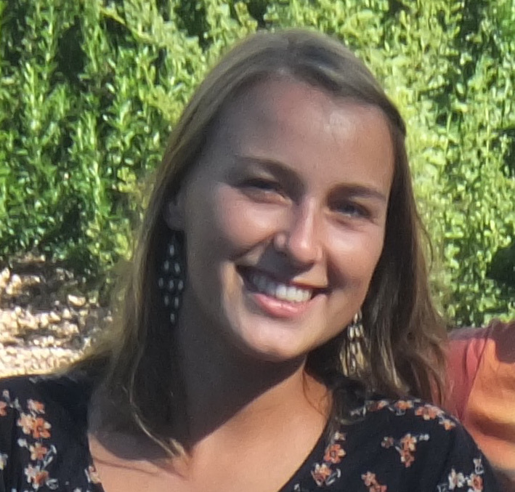

Psychologist, Trainer and Adventure Therapist at NATURE ([www.nature.be](http://www.nature.be)), Belgian ATIC representative and coordinator of the European AT partnership project ‘Reaching Further’

Working with vulnerable youngsters and adults in an outdoor setting since 2010.

[LinkedIn](https://www.linkedin.com/in/lynn-van-hoof-b53175113?trk=nav_responsive_tab_profile_pic) Lynn // [lynn@nature.be](mailto:lynn@nature.be)